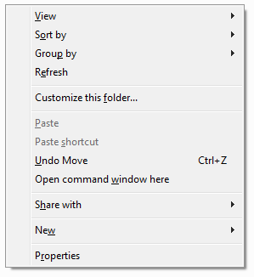

Shift + Right Mouse Click > Select “Open command window here” Under Windows 7

F:\Ubuntu_Desktop\georgexyz.com\output>C:\Users\George.Zhang\AppData\Local\Programs\Python\Python37\python.exe -m http.server 8000

The command above runs the python built in serve at port 8000.

Open browser and enter address

http://localhost:8000/